# Proposal for Project Work

# Team members:

1. Abhiyan Lamsal

2. Sagun Sapkota

3. Diwas Sharma

**Faculty**: CSIT III 'A'

**Title:** Namaste Nepal

**Start date:** 2021-06-20

**End Date:** 2021-11-22

**Project work type:** HTML/CSS/JS Mini project

**Introduction**

Namaste Nepal is specially designed for purpose of serving tourism industry in Nepal. Coming to Nepal is coming to an experience that is only yours. From the remotest corners to the urban landscape, Nepal embodies a sensory experience of colours, sounds, sights and tastes. Namaste Nepal welcomes you to Nepal for life’s amazing moments.

**Background**

The site is built to serve international or domestic individual or group travels. Technology and expectations have change to enable us to build a better site to serve the community. We are looking to build a distinctive modern site to reflect the diversity, character and uniqueness of Nepal. It needs to be responsive for mobile devices, intuitive to easily find information and accessible to the entire community and visitors.

**Objectives**

* Website will use CMS (content management system) platform with a clear, intuitive and easily searchable design so thatvisitors are able tomaximize their enjoyment of living, working or even visiting the Nepal for the first time.
* The site will provide links to external databases, GIS mapping information, online utility payments, and engagement tools and social networking.
* There is so much the Nepal has to offer and we feel, through superior design, that we can convey the dynamic energy and diversity to all who visit the site.

**Expected outcomes**

* Researcher interface that provides easy access to information and easy to navigate vising places.
* The site will require timely updates, the process to update must be simple and efficient using several sections or template types and corresponding cascading style sheets so the current and future staff will be able to easily update the content, news, calendar, building data and generally maintain the site.
* The home page will highlight blogs and social media posts to engage the public.

**Methodology**

* **Preliminary Study**

We learnt basic Html/css/js from teacher who helped us to build this site. Also researches about topic on internet have sharpened our skills to build a distinctive modern site.

* **Design** Home page contains header, content section and footer. Header hosts many navigation links for visitors such as top destination, events and festival, gallery etc. Little sneak peek of site GUI is shown below:

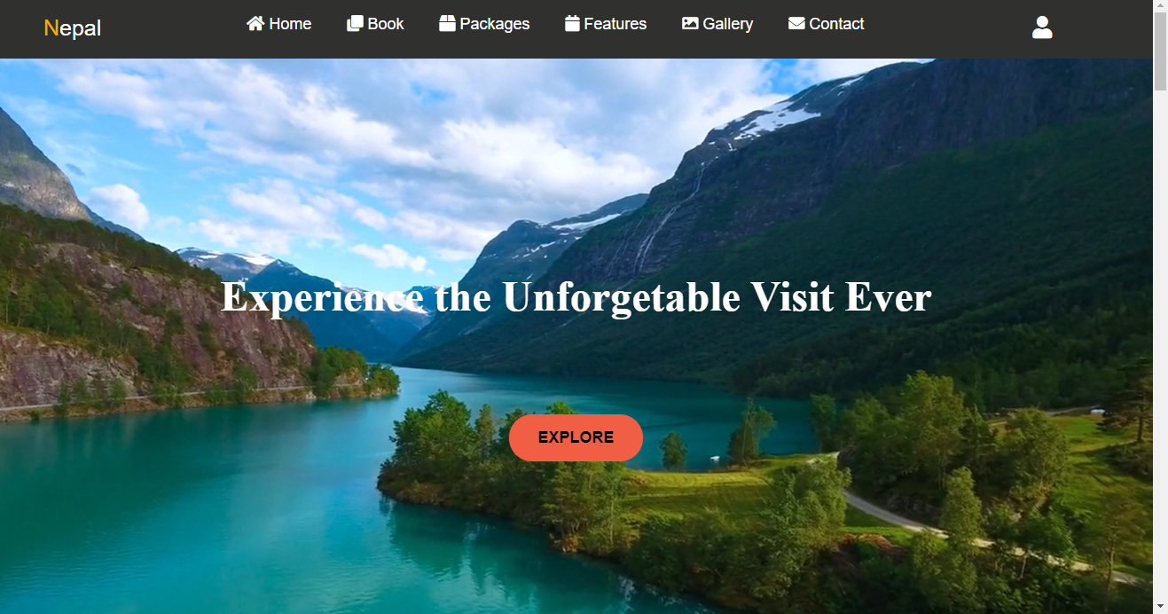

* **Implementation/ Coding**

The site was built and implemented with help of CMS platform like visual studio code and sublime text. We have enabled our site to run in any search engines and devices.

**Time plan**

Week 1st: Title finalization.

Week 2nd: Finished writing Proposal and submitted.

Week 3rd: Research on the topic.

Week 4th: Work distribution.

Week 5th -8th: Coding began.

Week 9th: Documented submitted.

Week 10th: Final defense.

**References**

Friends and teachers are our references for this project.